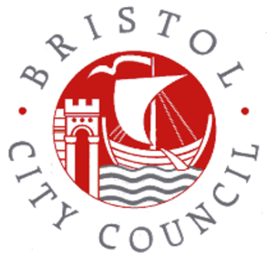
Hello Parents and Carers
Bristol City Council would like to know if your wrap around childcare (before or after school) is meeting your needs.
Please complete this quick survey. It’s completely anonymous.
https://forms.office.com/e/Nuv0CftB6i
If you have a smart phone, open your camera and focus on the QR code to go straight to the survey!
Thank you, Bristol City Council

