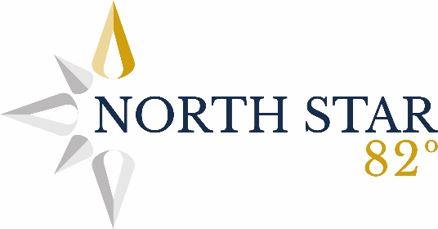
PSHE Curriculum Statement

PSHE statement - What Is Our Vision for PSHE?
At North Star 82°, we are committed to providing every pupil with access to a personalised curriculum that reflects their individual needs, interests, and life experiences. Our PSHE curriculum has been thoughtfully designed to meet the unique contexts of our learners, considering their backgrounds, lifestyles, and emotional needs.
The curriculum is structured to support the development of the whole child through engaging, well-planned, and well-resourced lessons. These lessons equip pupils with the knowledge, skills, and attributes needed to promote and protect their wellbeing. Through PSHE, pupils learn how to stay safe and healthy, form and maintain positive relationships, and take an active, responsible role in their community. It also meets the statutory requirements of the 2020 Relationships, Sex and Health Education guidance.
Beyond this, our PSHE programme plays a vital role in supporting pupils’ spiritual, moral, social and cultural (SMSC) development, alongside their behaviour, safety, and overall emotional wellbeing. It also underpins our commitment to promoting British Values: democracy, the rule of law, individual liberty, mutual respect, and tolerance of those with different faiths and beliefs.
Intent
At North Star Academy Trust, our PSHE curriculum is central to the development of the whole child, particularly for those with social, emotional and mental health needs. We aim to help children increase their mental wellbeing, develop self-esteem and confidence, and gain the life skills needed to function as active, valued members of society—both now and in the future. Our curriculum enables children to understand themselves and others, take an interest in local and global issues, and recognise their passions and values. It supports them in developing positive relationships, understanding the role of money, appreciating family diversity, and preparing for employment. Above all, PSHE is the space where children learn to be safe, resilient, and reflective individuals who are equipped to manage life’s challenges with confidence and purpose.
Implementation
We use the Jigsaw Programme as our core PSHE framework, enhanced and adapted to meet the specific needs of our SEMH learners and our safeguarding data. Jigsaw is a clear progressive curriculum which leads children through through six ‘Jigsaw Pieces’ – Being Me in My World, Celebrating Difference, Dreams and Goals, Healthy Me, Relationships and ‘Changing Me’. PSHE is delivered through weekly, age-appropriate lessons that are adapted to reflect class needs, safeguarding data, and real-life issues relevant to our children. When necessary, bespoke lessons are created to respond to specific concerns. Lessons are rooted in real-world scenarios to help pupils make meaningful connections and are further supported through assemblies, themed weeks, and awareness days. Our trained Anti-Bullying Ambassadors promote tolerance and kindness, playing an active role in modelling healthy peer relationships. We also build cross-curricular links, especially with science, PE and DT, to reinforce concepts related to healthy living and growing up.
Relationships and Sex Education (RSE) is taught in a carefully planned in an age-appropriate and sensitive way throughout the school to ensure that children are appropriately educated with the correct and legal information.

Impact
Our PSHE curriculum prepares pupils to transition to secondary education with a strong sense of self-worth, emotional awareness, and the ability to form safe and healthy relationships. We see children develop greater resilience, happiness, and wellbeing, and they begin to approach life with curiosity, empathy, and responsibility. They understand their place in the wider world, are able to contribute positively to their community, and recognise how to stay safe—both online and offline. As a result, children are not only better prepared for the next stage of their education but also for life beyond the classroom, as confident, thoughtful, and socially aware individuals.

