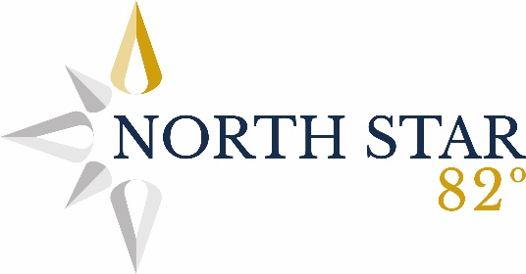

Project-Based Learning (PBL) – 3 I’s Statement
Intent
At North Star 82, our intent in delivering a project-based learning (PBL) curriculum is to provide learning that is meaningful, accessible and effective for our pupils. We recognise that many of our children, including those with social, emotional and mental health (SEMH) needs, learn best through practical, pupil-centred experiences that build real understanding, confidence and emotional security.
Our PBL curriculum is designed to give pupils ownership of their learning by encouraging them to ask questions, explore ideas and take an active role in their education. Projects are rooted in real-world contexts so that learning feels purposeful and relevant. Alongside subject knowledge, we intentionally develop key life skills such as communication, teamwork, resilience, emotional regulation, problem-solving and critical thinking. These skills support both academic progress and pupils’ social and emotional development, enabling them to engage positively with learning and with others.
Implementation
Our PBL curriculum is delivered through carefully structured projects that integrate learning across subject areas while remaining flexible and responsive to individual needs. Each project is built around a meaningful question or challenge linked to real-life contexts, helping pupils understand why their learning matters.
Teaching staff provide clear routines, consistent expectations and appropriate scaffolding to support pupils with SEMH needs. Learning is broken into manageable steps, with opportunities for choice, reflection and success built into each project. Adults act as facilitators, modelling thinking, supporting emotional regulation and providing targeted intervention where needed.
Pupils work both independently and collaboratively, developing communication skills and positive relationships through shared problem-solving and creative outcomes. Assessment is ongoing and formative, allowing staff to adapt learning, provide reassurance and celebrate progress in both academic learning and social and emotional development.
Impact
As a result of our project-based learning curriculum, pupils are more engaged, motivated and invested in their learning because it is purposeful, relevant and hands-on. Pupils demonstrate increased confidence, independence and pride in their work, taking greater ownership of their learning over time.
For pupils with SEMH needs, PBL has a positive impact on emotional wellbeing, self-esteem and behaviour for learning. Predictable project structures, meaningful outcomes and supportive adult relationships help reduce anxiety and increase pupils’ sense of safety and belonging. Pupils show improved emotional regulation, resilience and perseverance when faced with challenge.
Collaborative project work supports the development of communication skills, empathy and positive peer relationships. Over time, pupils show improved engagement, reduced avoidance behaviours and increased readiness to learn. Pupils leave projects with secure subject knowledge alongside transferable life skills that support long-term wellbeing, successful learning and positive outcomes beyond North Star 82.

